
CATHOLIC JUNIOR COLLEGE
H
Preliminary Examination 2010
Higher 2

CANDIDATE
NAME
CLASS
2
T

CHEMISTRY 9647/02

Paper 2 Structured 13 September 2010

Candidates answer on the Question paper 2 hr
Additional Materials: Data Booklet

READ THESE INSTRUCTIONS CAREFULLY
Write your name and class in the spaces provided above.
Write in dark blue or black pen.
You may use a soft pencil for any diagrams, graphs or rough working.
Do not use staples, paper clips, highlighters, glue or correction fluid.

You are reminded of the need for good English and clear presentation in your answers.
The number of marks is given in brackets [ ] at the end of each question or part question.

Answer all questions.
A Data Booklet is provided.
For Examiner’s Use
Q 1
Q 2
Q 3
Q 4
Q 5
Q 6
72


This document consists of 12 printed pages and 0 blank page.

CJC Chemistry Department

© CJC 2010
1 Planning (P)

New Zealand green-lipped mussels are rich in omega-3 fatty acids. Freeze-dried tissues of such mussels are sold in many countries as nutritional supplement to relieve arthritic symptoms.
Mussel shells are a good source of calcium carbonate and may be used as ‘fertilisers’ to regulate soil acidity. When hydrochloric acid is added to mussel shells, the following reaction occurs.
CaCO₃(s) + 2HCl(aq) → CaCl₂(aq) + CO₂(g) + H₂O(l)
You are to determine the percentage of calcium carbonate in a 1.0 g sample of mussel shell fragments by a back titration method.
The shell fragments are first treated with an excess of hydrochloric acid and the unreacted acid is then determined by titration with standard sodium hydroxide solution.

(a) Calculate the minimum volume of 1.0 mol dm^{–3} hydrochloric acid that must be added to the 1.0 g sample of mussel shell fragments for complete reaction to occur.

M_{r} of CaCO₃ = 40.0 + 12.0 + 3(16.0) = 100
mol of CaCO₃ =
= 0.010 mol
mol of HCl = 2 × mol of CaCO₃ = 2 × 0.010 = 0.020 mol
∴ vol of HCl =
× 1000 = 20 cm³

[2]

(b) Upon complete reaction of the calcium carbonate in a 1.0 g sample of mussel shell fragments, the excess unreacted hydrochloric acid was diluted to prepare a 250 cm³ standard solution for titration with 0.10 mol dm⁻³ sodium hydroxide solution.

- If 25.0 cm³ of sodium hydroxide solution was required to react with 25.0 cm³ of the standard solution of hydrochloric acid prepared, calculate the number of moles of HCl present in the 250 cm³ standard solution prepared.

mol of NaOH = 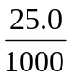 x 0.1 = 2.5 x 10⁻³ mol
mol of HCl in 25.0 cm³ std solution = 2.5 x 10⁻³ mol

mol of HCl in 250 cm³ std solution = 0.025 mol

- If 40.0 cm³ of the original 1.0 mol dm⁻³ hydrochloric acid was added to the 1.0 g sample of mussel shell fragments, calculate the number of moles of CaCO₃ present in the sample of mussel shell fragments and hence determine the percentage by mass of CaCO₃ in the mussel shells.
Total mol of HCl added to react with mussel shells = 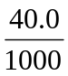 x 1 = 0.04 mol
mol of HCl reacted with CaCO₃ = 0.04 – 0.025 = 0.015 mol mol of CaCO₃ present in 1 g mussel shell =  x 0.15 = 7.5 x 10⁻³ mol
mass of CaCO₃ present in 1 g mussel shell = 7.5 x 10⁻³ x 100 = 0.75 g

% by mass of CaCO₃ present in mussel shell = 0.75 / 1 x 100% = 75%
[4]
(c) Outline the procedure you would carry out in the back titration method. In your description, you should include details of the apparatus and chemicals used and measure(s) taken to ensure reliability of results.

1. Using a burette, run 40.00 cm³ of 1 mol dm^{–3} HCl into a 100 cm³ beaker containing the 1.0 g sample of mussel shell fragments. Reaction is complete when there is no more effervescence of CO₂(g).

2. Filter with a filter funnel and filter paper to remove any impurities.
3. Transfer the filtrate and washings into a 250 cm³ volumetric flask and make up to the mark with distilled water. Shake well to obtain a homogeneous solution.

4. Pipette 25.0 cm³ of diluted HCl (from the volumetric flask) into a 250 cm³ conical flask.
5. Add 2 drops of phenolphthalein indicator.

6. Titrate with 0.10 mol dm^{–3} sodium hydroxide (placed in a 50 cm³ burette) until the solution in the conical flask changed from colourless to pink.

7. Repeat the titration until consistent results (two titres within ±0.10 cm³) are obtained.

[4]

(d) An alternate method to determine the percentage of calcium carbonate in mussel shells involves measuring the volume of carbon dioxide gas evolved when an excess of hydrochloric acid is added. Draw a labelled diagram of the apparatus (set-up) that could be used to collect and measure, as accurately as possible, the volume of carbon dioxide gas produced.
divided flask / thistle funnel
graduated gas syringe / collected over water saturated with CO₂(g)

[2]
[Total: 12]
2 In atmospheric pollution, nitrogen oxides commonly refer to a mixture of nitric oxide, NO, and nitrogen dioxide, NO₂, collectively represented as NO_{x}.

- Nitrogen dioxide, NO₂, a reddish-brown toxic gas with a characteristic sharp, biting odour is widely used as an intermediate in the Ostwald process for the industrial synthesis of nitric acid, as shown in the equation below:
3NO₂ + H₂O → NO + 2HNO₃
Explain what is meant by disproportionation with reference to the reaction shown above, clearly stating the species and change in oxidation states involved.

Disproportionation for the above reaction is the simultaneous reduction of N from +4 oxidation state in NO₂ to +2 oxidation state in NO as well as oxidation from +4 oxidation state in NO₂ to +5 oxidation state in HNO₃.

[2]

(b) Nitrogen dioxide, which can be classified as a free radical, exists in equilibrium with dinitrogen tetroxide, N₂O₄, a powerful oxidiser which is highly toxic and corrosive.
N₂O₄(g) 2NO₂(g)
- Draw the dot-and-cross diagrams of NO₂ and N₂O₄.

- A mixture of the two gases are allowed to reach equilibrium in a gas syringe. State and explain how an increase in the volume occupied by the gases in the syringe would affect the equilibrium position and hence the composition of the mixture at equilibrium under constant temperature.

When volume occupied by gases in syringe increase, pressure decreases,
According to Le Chatelier’s Principle, POE shifts right to favour reaction with greater number of moles of gas to increase pressure
Eqm mixture contains more NO₂ and less N₂O₄

- The equilibrium constant K_{c} of a reaction is related to the absolute temperature, T (in Kelvin), of the reacting conditions via the equation:

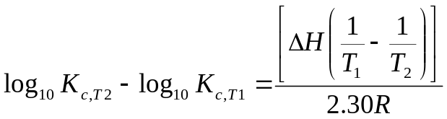

where a change in temperature from T₁ to T₂ changes the equilibrium constant from K_{c},_{T1} to K_{c},_{T2} respectively and R is the molar gas constant.

Given that the equilibrium constant changes from 0.05 mol dm⁻³ at 300 K to 15 mol dm⁻³ at 400 K for the above reaction, calculate the enthalpy change for the reaction. State a major assumption made in this calculation.

log₁₀15 – log₁₀0.05 = [ΔH (1/300 – 1/400)] / (2.30 x 8.31)

ΔH = 56814 J mol⁻¹ or 56.8 kJ mol⁻¹

Assumption is that ΔH remains constant at 300 K and 400 K

- Predict the sign of ΔS for the reaction N₂O₄(g)2NO₂(g), showing your reasoning.

∆S is positive. Products contain a more number of moles of gas/ There is an increase in number of gaseous particles (i.e. 1 mole → 2 moles).

- Using your answers from part (iii) and (iv), deduce how the spontaneity of the reaction changes with temperature.

∆G = ∆H - T∆S
Since ∆H is positive and ∆S is positive (-T∆S is negative)
Hence, ∆G is positive at low temperature and negative at high temperatures.
Reaction is non-spontaneous at low temperature & spontaneous at high temperature or reaction becomes more spontaneous with increasing temperature.
[10]
[Total: 12]

3 (a) In the process of refining crude oil, shorter and useful hydrocarbons are obtained through catalytic cracking. Silica, SiO₂, a catalyst used in catalytic cracking, can be obtained by the hydrolysis of silicon chloride, SiCl₄.

Enthalpy change of atomisation of Si | +338 kJ mol⁻¹
Enthalpy change of formation of SiCl₄(g) | -610 kJ mol⁻¹

Using the above information and relevant data from the Data Booklet, complete an energy level diagram and hence calculate the average bond energy of Si-Cl. [4]

Si (g) + 4Cl (g)
Energy

2BE(Cl₂) = 2(244)
4BE(Si-Cl)
Si (g) + 2Cl₂ (g)
∆H_{atm} (Si) = 338

Si (s) + 2Cl₂ (g)
0

∆H_{f} (SiCl₄) = -610

SiCl₄ (g)

-BE(Cl₂) = 244 [1, quote /use with the correct conversion]
-Includes (For correct and complete cycle):
1. Arrow pointing in the correct direction with the correct initial and final states,
2. Labeled arrows with correct coefficient,
3. Balanced correct element/compound with state symbols

By Hess’ Law,
4BE (Si-Cl)= -(-610) + (338) + 2(244)
BE (Si-Cl) = +359 kJ mol⁻¹

- Through catalytic cracking of decane, a variety of hydrocarbons such as methane, propane and cyclohexene can be obtained.

1.50 g of cyclohexene, C₆H₁₀ was burned under a container of 125 g of water causing a temperature rise of the water from 15 ºC to 75 ºC. The process was found to be 80% efficient and carbon dioxide is emitted in the process.

(i) Calculate the standard enthalpy change of combustion of cyclohexene, assuming that specific heat capacity of water is 4.20 J g⁻¹ K⁻¹.

Energy required to heat 75 g of water from 15 ºC to 75 ºC
= 125 x 4.20 x (75-15)
= 3.15 x 10⁴ J

Since the process is only 80% efficient,
Energy evolved from burning 1.50 g of cyclohexene
= 3.15 x 10⁴ x 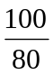
= 3.94 x 10⁴ J

Amt of cyclohexene used = 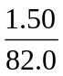 = 0.0183 mol
Enthalpy change of combustion
= - 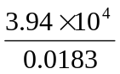
= - 2150 kJ mol⁻¹
Note: Alt method accepted as long as it is reasonable.

(ii) Suggest a reason why the process is only 80% efficient.
[4]
Heat loss to surroundings / Heat evolved to heat the container / Heat absorbed by container.

- For experimental safety, the recommended maximum limit for indoor air quality is 600 parts per million by volume (600 ppmv) of carbon dioxide. Given that a typical room measures 5 m x 5 m x 3 m, calculate the amount of carbon dioxide gas required to reach the recommended maximum limit at r.t.p. [2]

Volume of air in the room = (5)(5)(3) = 75 m³

600ppmv of CO₂ = 600 m³ of CO₂ in 10⁶ m³ of air

Volume of CO₂ needed = 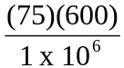
= 0.045 m³
= 45000 cm³
= 45 dm³
Amount of CO₂ required to reach the limit = 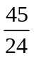
=1.88 mol

- Chlorofluorocarbons (CFCs), such as CCl₃F, can be synthesized through free radical substitution reaction of methane. They are a class of chemically stable compounds and were once widely used in daily life in aerosol sprays. However in recent years, CFCs has been replaced by hydrofluorocarbons (HFCs), such as CH₃CHF₂, as CFCs contribute to ozone depletion.

Given that the bond energy of C-F is 485 kJ mol⁻¹, explain why CFCs are being replaced by HFCs, with the use of relevant data from the Data Booklet. [2]

The bond energy of C-Cl is 340 kJ mol⁻1 and C-F is 485 kJ mol⁻¹.
It will require more energy for homolytic fission to take place for C-F bond thus it is harder to produce F•, as compared to Cl• (or simply produce radicals)
[Total: 12]

4 Silver and copper have similar outer electron configurations but their chemical behaviour differs.

(a) By considering the electronic configuration of copper atoms, complete the electronic configuration of silver.

Ag 1s²2s²2p⁶3s²3p⁶3d¹⁰4s²4p⁶ 4d¹⁰ 5s¹…………… [1]

(b) Silver(I) sulfate has limited solubility in water but when it is stirred into aqueous potassium iodide, a yellow precipitate A forms.

When copper(I) sulfate is stirred into water, a pinkish brown solid B separates from a blue solution C. When aqueous potassium iodide is added to C, a white precipitate D forms in a brown solution E.

State the chemical formulae for substances A to E. [5]

A : AgI…………………………

B : Cu…………………… C : CuSO₄ or [Cu(H₂O)₆] SO₄

D : CuI ………………… E : I₂ / KI₃……………………

(c) Marine aquarists are generally very concerned about pH in aquariums because aquatic organisms can only thrive in a particular pH range. To measure the pH, one can use a pH meter. The probe on a pH meter has two electrodes, one is a glass electrode that responds to changes in [H⁺(aq)] and the other a reference electrode that must have a stable electrode potential. The reference electrode is very often a silver electrode dipping in a saturated solution of 0.10 mol dm⁻³ KCl in contact with AgCl(s). The solubility product for AgCl is 2.0 x 10⁻¹⁰ mol² dm⁻⁶.

(i) Calculate the [Ag⁺(aq)] in the reference electrode.
[Ag⁺] = 2.0 x 10⁻¹⁰ / 0.1 = 2.0 x 10⁻⁹ mol dm⁻³

(ii) The electrode potential, E, changes from the standard value, E^{ө}, if the concentration of the ions is non-standard. This change is given by the Nernst equation.
E = E^{ө} + 0.059 log [Ag⁺(aq)]
Calculate the electrode potential of the silver reference electrode at 298 K.
E = 0.80 + 0.059 log 2.0 x 10⁻⁹
= 0.286 V

(iii) The potential of the glass electrode also changes according to the Nernst equation
E = E^{ө} + 0.059 log [H⁺(aq)]
If a pH meter operates over the range 0-14, what is the range of the voltage output of the pH meter?
E = 0 - 0.059 pH
Min voltage = 0 V
Change in voltage output = - 0.059 * 14 = - 0.826V
Range of the voltage output: -0.826V to 0V

(d) Before use, a pH meter is calibrated using a buffer solution of pH 4.00. It contains 0.0113 mol dm⁻³ methanoic acid and 0.0200 mol dm⁻³ sodium methanoate.

Calculate the K_{a} for methanoic acid. [2]

4 = pK_{a} + lg (0.0200 / 0.0113)
K_{a} = 1.77 x 10⁻⁴ mol dm⁻³
[Total: 12]

5 Orthocaine is a local anaesthetic that causes temporary loss of pain.
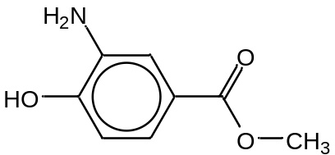

(a) Name two functional groups present in the molecule. [2]
Phenol, Phenylamine, Ester (Any 2)
(b) Draw the structural formulae of the organic compounds formed when Orthocaine reacts with each of the following reagents. [5]
Reagents | Structural formula of organic product
Aqueous bromine | 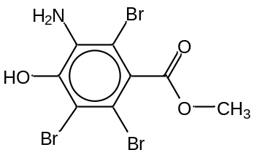
Cold HCl | 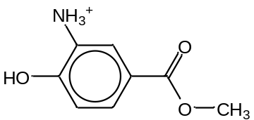
CH₃COCl | 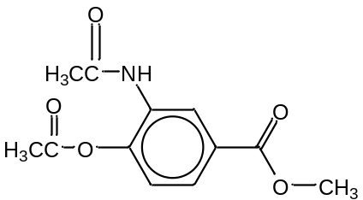

(c) Orthocaine can be formed from phenol as shown.
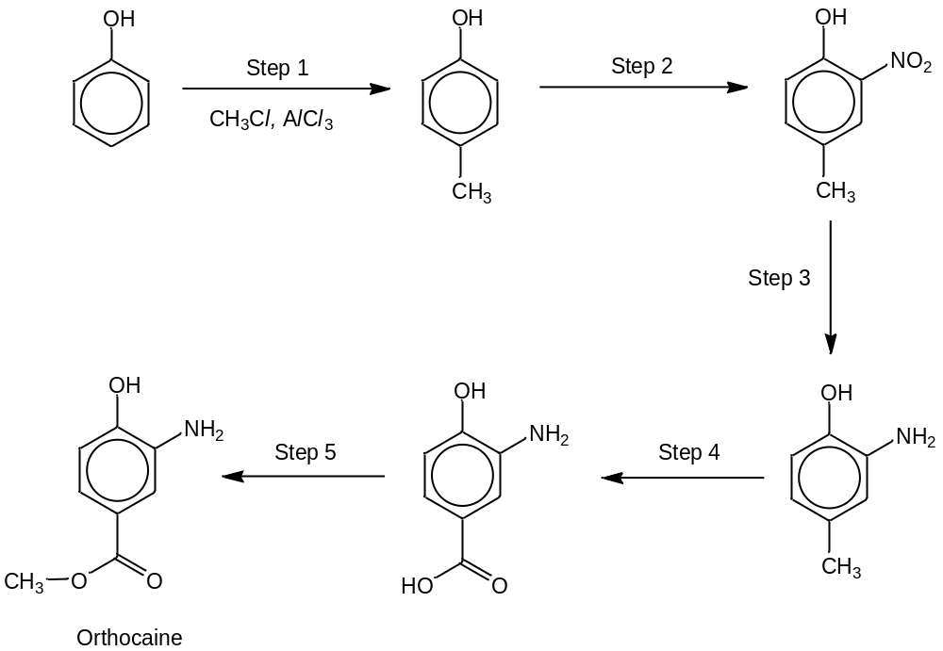

- Name the type of reaction that is occurring in Step 1.
Electrophilic Substitution…………………………………………………………

- State the reagents and conditions required for Steps 2 – 5 by completing the table below.
Steps | Reagents and conditions
2 | Dilute HNO₃
3 | 1. Sn/conc HCl, heat 2. aq. NaOH
4 | KMnO₄/H⁺, heat
5 | CH₃OH, trace amt. of conc. H₂SO₄, heat/reflux
[5]
[Total: 12]
6 (a) Limewater is a saturated solution of Ca(OH)₂, and is often used to test for the presence of CO₂ formed during experiments. A positive test is indicated by the formation of white precipitate, CaCO₃.

(i) Write an equation, with state symbols, to represent the reaction between limewater and CO₂.

Ca(OH)₂ (aq) + CO₂ (g) → CaCO₃(s) + H₂O(l)

(ii) The solubility of Ca(OH)₂ is 1.73 g dm⁻³. Calculate the concentration of Ca²⁺ in
mol dm⁻³, in limewater (saturated Ca(OH)₂ solution).
[Ca²⁺] of saturated solution = 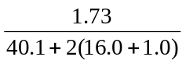= 2.33 x 10⁻² mol dm⁻³

(iii) Calculate the K_{sp} of CaCO₃ given that its solubility is 1.5 x 10⁻⁴ mol dm⁻³.

K_{sp}=(1.5 x 10⁻⁴)(1.5 x 10⁻⁴) = 2.25 x 10⁻⁸ mol² dm⁻⁶

(iv) Hence, calculate the minimum volume of CO₂ at r.t.p., that must be bubbled through 1 cm³ of limewater in order to give a white precipitate, CaCO₃. [6]

2.25 x 10⁻⁸ = (2.33 x 10⁻²) [CO₃²⁻]
[CO₃²⁻] = 9.66 x 10⁻⁷ mol dm⁻³
Number of moles of CO₂ = 9.66 x 10⁻⁷ x 1/1000 = 9.66 x 10⁻¹⁰ mol
Volume of CO₂ = 9.66 x 10⁻¹⁰x 24 = 2.32 x 10⁻⁸ dm³ at r.t.p.

(b) The carbonates of Group II elements, similar to their nitrates, can be decomposed by heat.

(i) Write a balanced equation for the thermal decomposition of MgCO₃.

MgCO₃(s) → MgO(s) + CO₂ (g)

(ii) Describe and explain the trend in thermal stabilities of the carbonates of Group II elements from Mg to Ba. [4]

Ionic charge remains constant at +2, but the ionic radius increases down the group. Hence the charge density decreases down the group.
Thus, the anions is less polarised by the cation and the electron clouds are distorted to a lesser extent.
Therefore, thermal stability increases down the group.

(c) Magnesium hydroxide and magnesium carbonate can both be used as flame retardant in fireproofing materials.

The following equation represents the thermal decomposition of magnesium hydroxide at an elevated temperature.

Mg(OH)₂(s) → MgO(s) + H₂O (g)

Given that ΔH = +81 kJ mol⁻¹ and ΔS = +151 J mol⁻¹ K⁻¹ for this reaction,

(i) Calculate the minimum temperature for this reaction to be spontaneous.

ΔG = ΔH - TΔS< 0

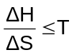 ∴ T < 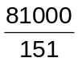< 537 K

(ii) Suggest a reason why both compounds can be used as flame retardants. [2]

The thermal decomposition is endothermic which will absorb heat from the fire preventing the fire from spreading.
OR

The products from the thermal decomposition, water and carbon dioxide, from hydroxides and carbonates respectively, can help to extinguish the fire.

OR

There is a sudden increase in gaseous molecules through the thermal decomposition which may displace oxygen and smother the flame.

[Total: 12]

